REFLECTIONS ON RESIDENCE (or “Risiedo: The State of Repeated Sitting”)

By Lisa Rubenstein Calevi

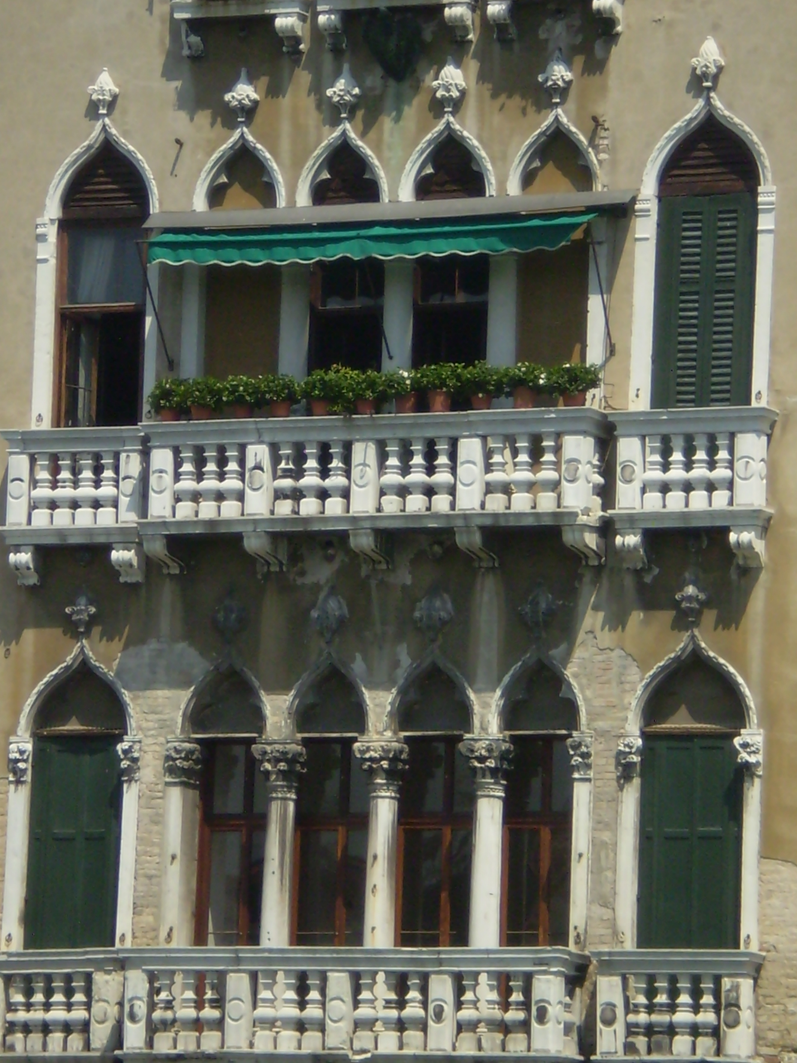
Venetian palazzo with shutters

The 2008 NEH Institute presented a vast array of topics concerning the Jewish experience, past and present, in Venice. All five weeks of the Institute were marked by intense intellectual exchange and focused analysis regarding the liminal status of the Jewish community in Venice from the fourteenth through twentieth centuries. Our interdisciplinary approach suggested that there were many ways to understand how and why the status of the Jews fluctuated during four centuries of Venetian ghetto life. We examined their unique history by studying the built environment, commercial relationships, social behaviour, intellectual contributions, religious worship, musical traditions, as well as both artistic and literary productions in which Jews were sometimes, but not always, depicted with derision.
Of most interest to me personally were insights about the Jews that emerged in our discussion of language; in particular, how the experience of “living in two languages”—as noted by one of our directors, Murray Baumgarten, during a discussion of Simone Luzzato’s Il Discorso—could provide another lens through which to examine the dual status of the Jews. How does one experience the state of living in two languages? After listening to our other director, Shaul Bassi, give the talk “Notes on the Judeo Venetian Dialect” I began to reflect upon how issues of language “spoke” to me on an intuitive level, as I, myself, have spent the last 14 years living in two languages.
While I have mastered many of the nuances, tonalities, and colloquial expressions of the Italian language, it will never be my native tongue. Inevitably, if I am talking to someone for the first time, it is not an uncommon for them to ask, “Lei di dov’è?” (or, Where are you from?) The controversial work of Edward Sapir and Benjamin Whorf regarding the relationship between language and thought (to which our final conference speaker, Bryan Cheyette, intriguingly made passing reference), reinforces the idea that language communicates something about who we are. Perhaps nowhere is that truer than in Italy, where accents are prominent identity signifiers, and where most Italians are remarkably adept at differentiating regional accents. Based on word use and inflection, Venetians can often discern in which of the six sestiere (local districts each approximating the size of large American mall) a local has grown up.
Where am I from? Such a simple question but such a problematic answer. Does the person asking mean “Where was I born?” “Where did I grow up?” or “Where do I presently live?” Regardless, the question has always produced significant psychic discomfort for me since it unequivocally implies that I am not from here. Having been posed this question so many times, I began to think about how this modern-day question may have resonated with the Jews of Venice within the context of our NEH Institute. I wondered, Jewish juridical status aside, did the Venetians ever make this same query of the Jews? More significantly perhaps, was there ever a point—prior to emancipation in 1866—at which this question was no longer asked of the Jews? Did speaking the local language and living one’s entire life in the lagoon ghetto ever form a nexus of actually being from there? I can’t help but think that these are important questions to ask in our study of the Jews of Venice.
I have, by now, learned how to respond to the apparently simple but still fundamentally unsettling question of personal provenance. I respond by saying that “I am from Oregon (Io sono di...) but I live in Verona (ma abito a...).” Historically speaking, to many Americans—and Jews—these have been separate questions requiring separate answers. However, even today, the concept of being from somewhere (if understood as birthright) and living there remain virtually inseparable concepts to most Italians. So how do we define residence? What does it mean to be from somewhere? In some ways, I believe that this is the very question that we have been asking in our work at the Institute, and maybe without fully realizing it.
In Italian, there is an expression that one can use to address the aforementioned question: Risiedo (meaning “I reside”). While thinking about questions of historic Jewish residence in Venice, I began to see the etymological structure of this Italain word in new ways. Risiedo is formed by the verb “to sit” (siedo) preceded by a prefix of repetition (ri), as in “I sit here many times” or “I sit here repeatedly”. The poetic charge of this word is a potent one, particularly in light of NEH participant Lisa Pon’s musings (earlier in our conference) about the way Jews might have physically experienced moving through the physical space of ghetto and its environs.
Thus, if we accept that the state of residence—the sense of residing somewhere—goes beyond the mere juridical conditions that permitted Jewish habitation in Venice (i.e., renegotiated charters) and enters into notions about repetition and—by association—familiarity, we should attempt to discern the degree to which Jews actually lived as residents, as opposed to sequestered foreigners. To answer this question, we must once again return to language as signifier. By the early 17th century, Leone da Modena grumbles about how few Venetians knew Hebrew anymore. Does residence imply or require knowledge of a local tongue? Did other foreign populations (Greeks, Slavs, Germans) residing in Venice speak Venetian? Does residence also mean freedom of movement, and if so, what constituted “enough” freedom (for instance, we know that the gates of the ghetto closed later in the winter months to accommodate commercial activity)? Would the Jews have predicated their experience of residency upon choice of habitation or profession or religious affiliation? Did it mean sitting repeatedly on the same metaphorical bench or could it also have meant shuffling around a bit, talking to new people, expanding literal and figurative views? Did it (again, in a metaphorical sense) mean that, once in awhile, the Jews of Venice could occasionally “stand up” for themselves? Most importantly, did these repeated sittings ever blend into an experience of home?
To answer this, we might return to language, which has the strange power to make us feel like simultaneous members of both a minority and majority. By definition, inside the ghetto, the Jews were a numerical majority, even if a ghetto necessarily connotes a de facto space of minority marginalization. By all accounts, Jews residing in the ghetto spoke the language of the majority living outside its gates. Was this a deliberate gesture on the part of the Jews to soften the edges of marginalization, or merely a prerequisite of doing business with the Venetians? How did Venetians react to their native tongue being spoken by Jews? Was it more difficult to sustain the idea of The Other when Jews could converse in the lagoon dialect? These are the new questions that arise when I am asked—even after years of voluntary exile in Italy—“Where are you from?” More importantly, they remind me that speaking the language of the majority does not necessarily correlate with perception of residence (“being from here”) on the part of the native majority. Without fail, this question has the power to swiftly return me—if not to a ghetto, per se—then to the status of minority (i.e., not from here).
As an art historian, I find myself searching for an emblematic image of this strange status. Not surprisingly, I found it in the form of a wooden, slatted shutter—what we call a Venetian blind in English. The shutters that adorn many a Venetian palazzo are, of course, not really blinds at all, for light both enters and exits them (is nothing in Venice absolute?!) To those looking out from the inside, the slats allow a partially obstructed view of goings-on at street level and beyond; to those on the outside, however, nothing can be seen of either inhabitant or habitation. Did the gates of the ghetto function as a kind of metaphorical Venetian blind? Did Jews behind the shutter/gates derive a false sense of belonging to the greater Venetian urban fabric because they could witness the daily activities of Venetians and understand the language in which they were taking place? Or would those on the outside have relegated the Jews behind the shutter/gates to the realm of the invisible and unknowable, even if verbal communication remained possible? Like inhabited spaces (even ghettoes) languages have doors, windows, roofs and floors—that is, structure, limits, boundaries. Was language a boundary or a bridge for the Jews of Venice? For me, it has been both, and will necessarily inform my teaching of “Jewish Venice: Context & Culture”.
Remarks, now slightly reworked, made in conjunction with a talk given on 7/17/08 outlining a syllabus for use in a course entitled “Jewish Venice: Context and Culture” to be taught at the University of Oregon, Spring 2009.

Preliminary syllabus attached.

